**2ND QUIZ REPORT**

**DESIGN AND ANALYSIS OF ALGORITHM**



**BY:**

* **HONESTA SWANDARU         05111640000055**
* **DENNAS HASSEL ADJANI     05111640000113**
* **KURNIAWAN ADJI SAPUTRO    05111640000142**

**INFORMATICS DEPARTEMENT**

**TECHNOLOGY AND INFORMATION FACULTY**

**INSTITUT TEKNOLOGI SEPULUH NOPEMBER**

**SURABAYA**

**2019**

**STATEMENT LETTER**

**STATEMENT LETTER**

By the name of Allah (God) Almighty, herewith I pledge and truly declare that I have solved quiz 1 by myself, didn’t do any cheating by any means, didn’t do any plagiarism, and didn’t accept anybody’s help by any means. I am going to accept all of the consequences by any means if it has proven that I have been done any cheating and/or plagiarism.

|  |  |  |
| --- | --- | --- |
| Surabaya, 29 March 2019  https://lh6.googleusercontent.com/je-3R5DZO0Yses3BMWwMFPsmR9Kl3yaf-6DzhbYsCoFHVc9ccwWJK8JkE7WucYi-NxvoWDyYn48ENmuHzdKbs68jyJP83T7WUfL47Qa_dED7IaS87R6rJoaecQuEXM80odKT5XCj  Honesta Swandaru  05111640000055 | https://lh3.googleusercontent.com/xtiwg17GRRnLXteIMJz8ByQtozNLng3wrE7RSuRkPMkc2nbotbdXaNTLceC48qQtk7rRqe9FDbQ9PKeFop_jlliDoxuyJiUU_Rt4t3aBp3P7vNMUzLYA-BFzlj6HLlgAerqNeHkM  Dennas Hassel Adjani  05111640000113 | https://lh3.googleusercontent.com/9JvcYG2zuIlA6yDV101l2Y7FOSYMjt5STK5xEZCCGun2tN0ZvQ0PneJijglFklfuhj5q4OE2ZAIDDEKz4ZcYlZa84UgAe-ieNygEgkQTMOmRmo6xDrXhc2-aZsR_TwGs9MYKkm9F  Kurniawan Adji Saputro  05111640000142 |

For this second Quiz we’re making a game called “Number Guessing”. The player of this game divide into 2, use the player who guessing the number which already generated by Computer via random. If you want another player, you can do that.

In here We’re using BST to the computer to generating the number. If the player(s) guess(ess) lower than the randomed(?) number, then the computer will tell you that you need higher to guess and vice versa. If you can guess it, the game will break and and tell you how many you attempted to  guessed it and tell that you’ll win and vice versa.

In here We’re using Python Version 3.

**Source Code**

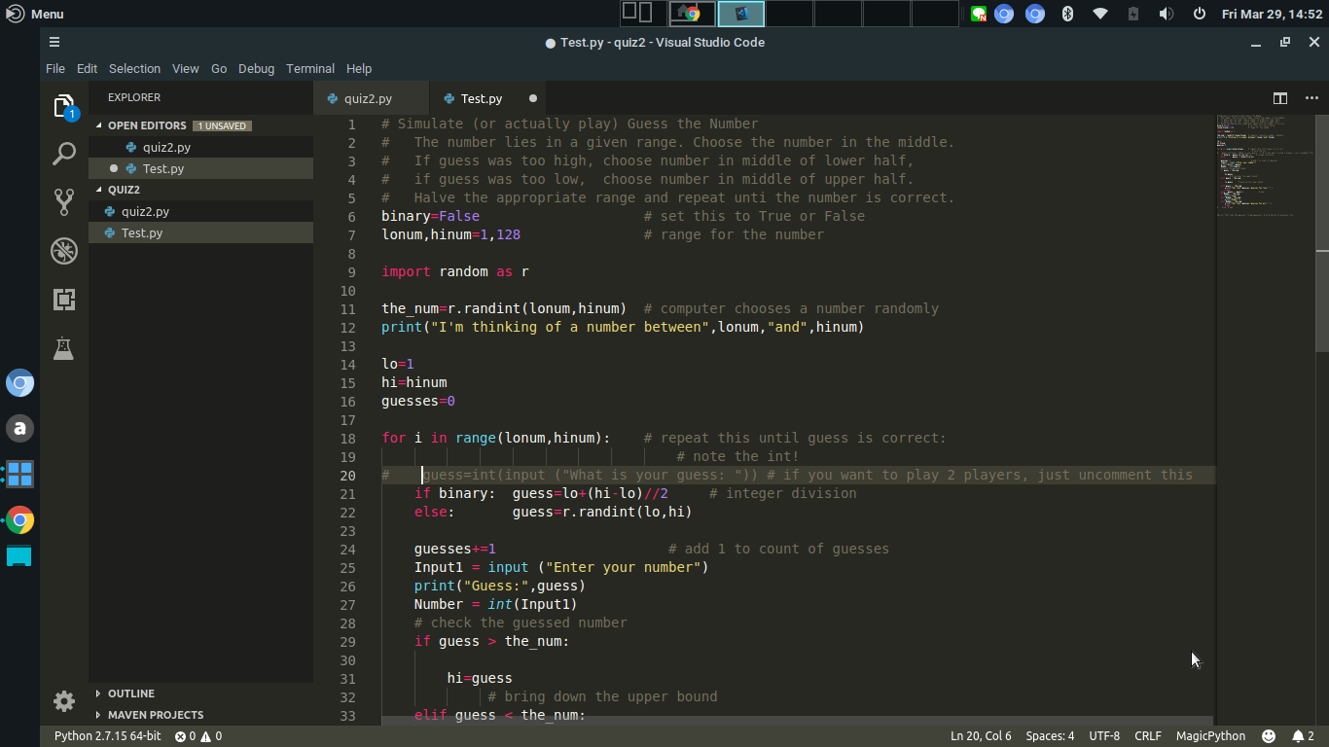

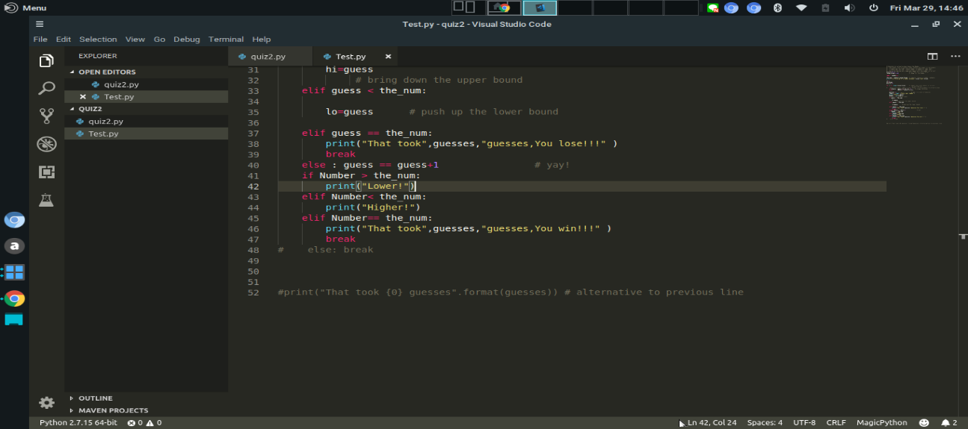

**Output**

